Construction Problems from the Sulba Sutras

Part I Explain why the following constructions are correct.

1. Baudhayana Verse I,50
To construct a square equal to the sum of two unequal squares.

Suppose the two given squares are ABCD and EFGH with AB > EF. Mark off points J, K on AB and DC with AJ = DK = EF. Then the line AK is the side of the required square.
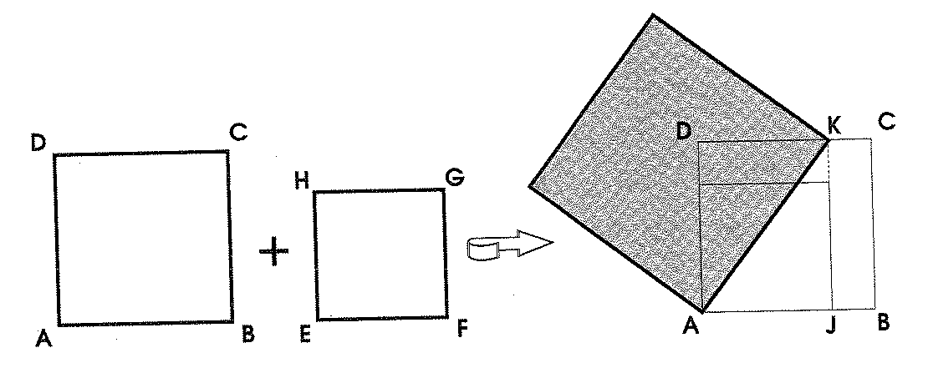

2. Baudhayana Verse I,51
To construct a square equal to the difference of two unequal squares.

Suppose the two given squares are ABCD and EFGH with AB > EF. Form an arc DL with center A. Then JL is the side of the required square.
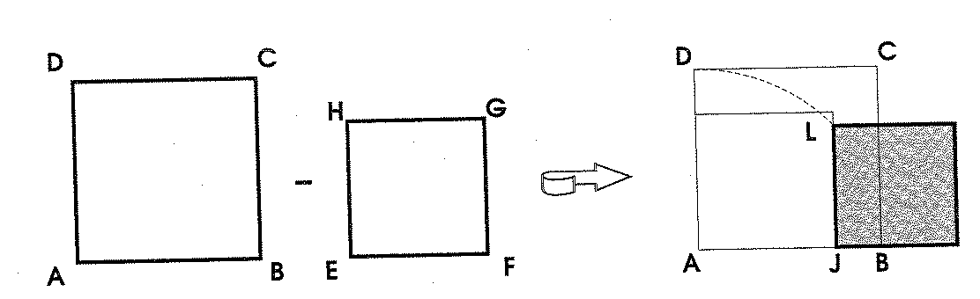

3. Baudhayana Verse I, 54
To construct a square with the same area as a given rectangle.

Suppose the rectangle is ABCD with AB > CD. Form a square AEFD. Cut the excess area into two equal parts and place one part on the side of the square. This gives two squares, a larger one AGJC’ and a smaller one FHJB’; the required square is the difference of these squares. (The side of the square is GL where L is determined by EL = EB’).

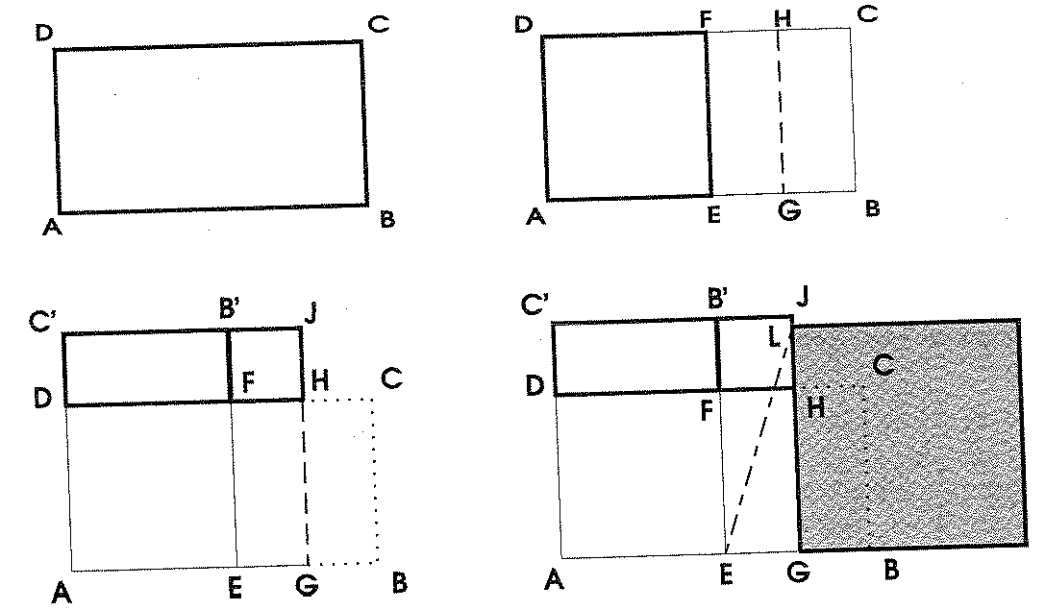

Part II An approximation of
The Sulba Sutras contain the approximation:

1. Some of the common measurement units measured in the Sulba Sutras are: prasada (hand span), where
angula (thumb width) 1 prasada = 12 angula
sesame seed 1 angula = 34 sesame seeds

Using a prasada as the unit measurement, write the approximation in terms of prasadas, angulas and sesame seeds.

2. The following construction technique was suggested by David Henderson of Cornell University to explain the derivation of this approximation.

a) Start with a rectangle of dimensions 1 prasada by 2 prasadas. Complete the first step of Versa I, 54 (constructing a square from a rectangle), as shown below.

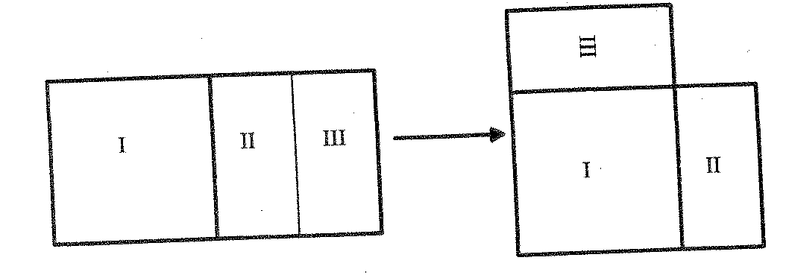
Find the dimensions of the right-most shape in prasadas and angulas.

b) Remove a thin strip from the left and bottom sides of width 1 angula. Cut the strips into lengths of 6 angulas and arrange them in the space in the top right as shown below.
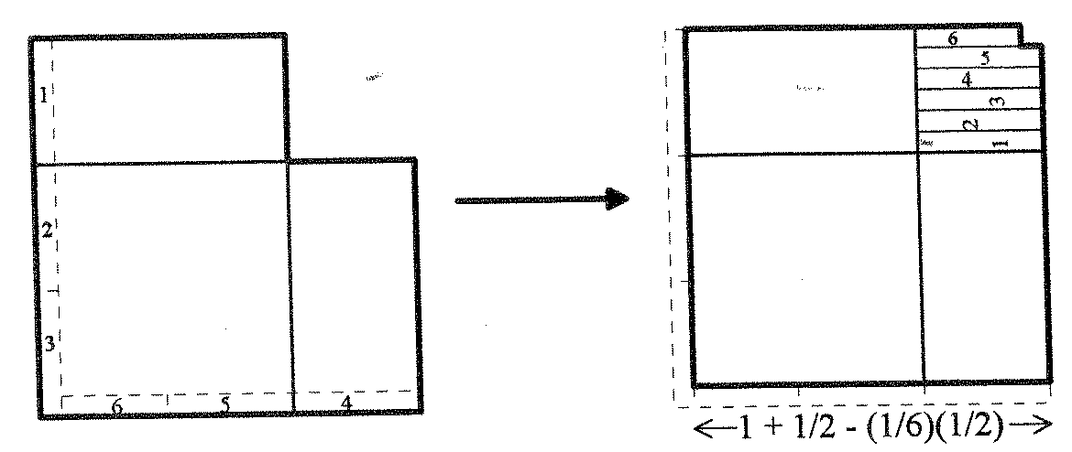
Why is there a small square missing in the corner? What is its dimension? What are the dimensions of the overall shape in prasadas and angulas?

c) Remove another strip of width 1 sesame seed. Cut the strips into lengths of 1 angula and arrange them in the space in the top right as shown below.
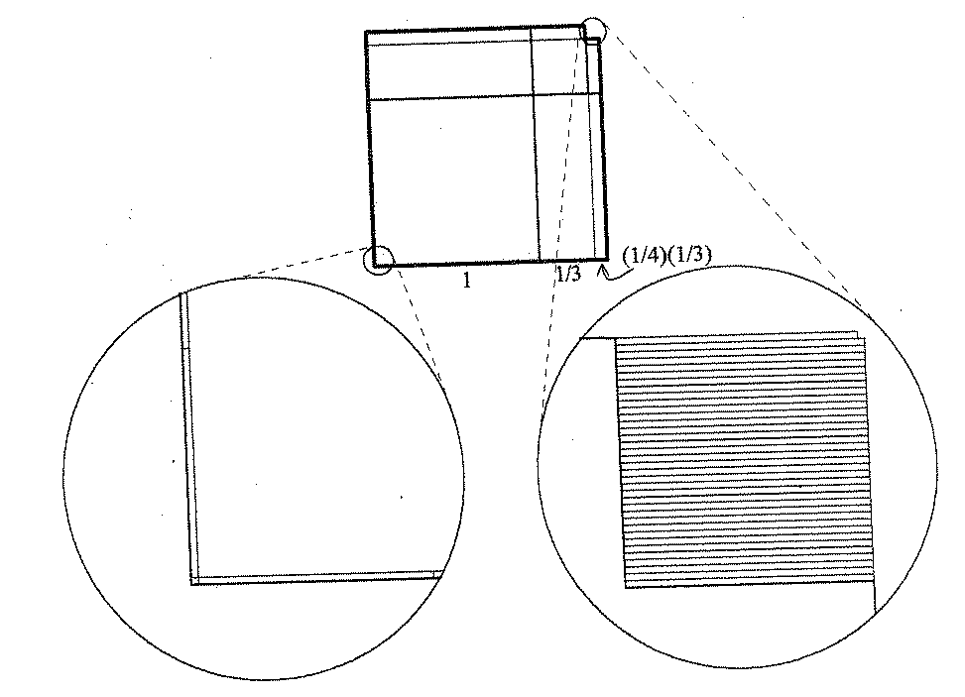
What is the dimension of the small square missing in the corner? What are the dimensions of the overall shape in prasadas and angulas and sesame seed?

d) How does this final shape yield the approximation of ?
Will the approximation be too big or too small?

Part III

The primary purpose of the Sulba Sutras is to describe temple or citi constructions. The citis consisted of 5 layers of brick, each of which contained roughly 200 bricks. The first, third and fifth layers had the same pattern; the second and fourth a different pattern.

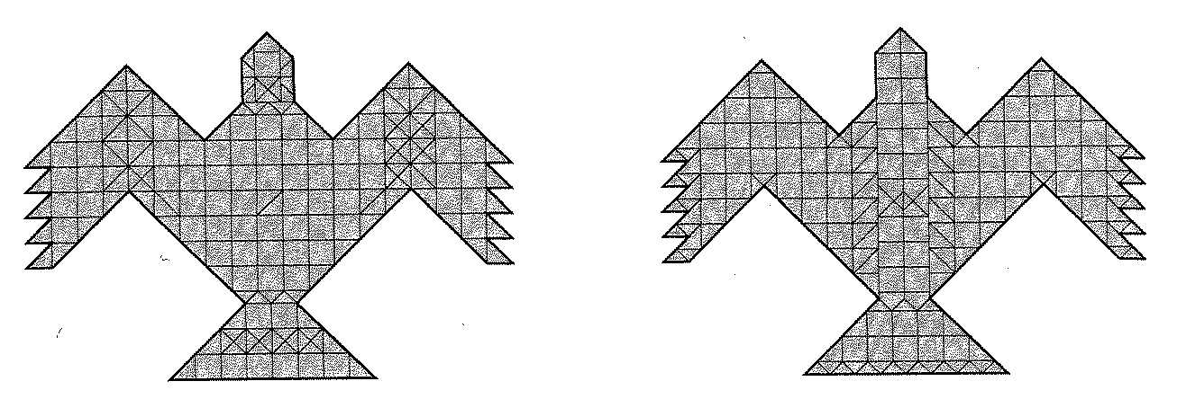

Layers 1, 3 & 5 Layers 2 & 4

Citis constructions were generally described in terms of purusas and angulas. (1 purusa = 10 prasada = 120 angulas)

Each layer was larger than the one below. Usually, the bottom layer was 7.5 sq. purusas; the next layer was 8.5 sq. purusas, etc. This was achieved by using larger and larger bricks.

1. Suppose you start with a 1 purusa x 1 purusa square that must be scaled up for the next layer of bricks. By what factor should the sides be scaled so that a total area of 7.5 sq. purusas is transformed into a total area of 8.5 sq. purusas? What square root would have to be constructed?

2 Baudhayana Verse II, 12 describes how a 1 purusa x 1 purusa square must be scaled up so that a total area of 7.5 sq. purusas is transformed into a total area that is q sq. units larger. What square root must be constructed?

